# Jenkins task for Day-01

1. Install jenkins and run jenkins on port number 8081.

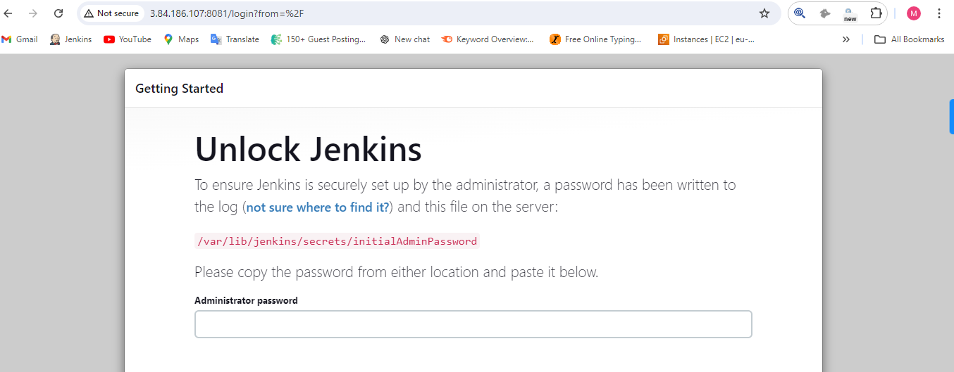

1. Secure Jenkins server.

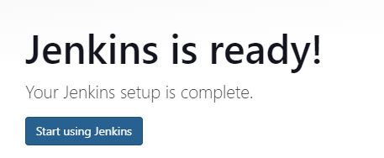

1. Create users called Devops, Testing in Jenkins with Limited access.

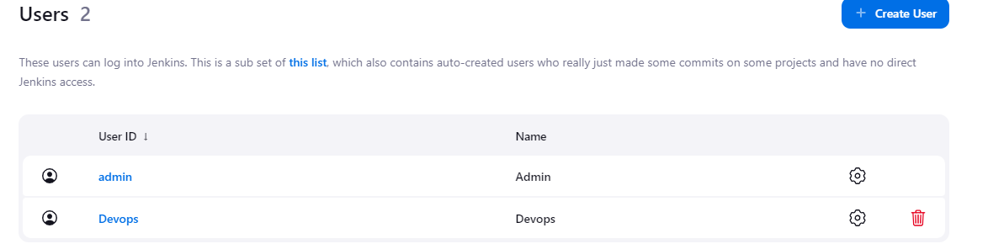

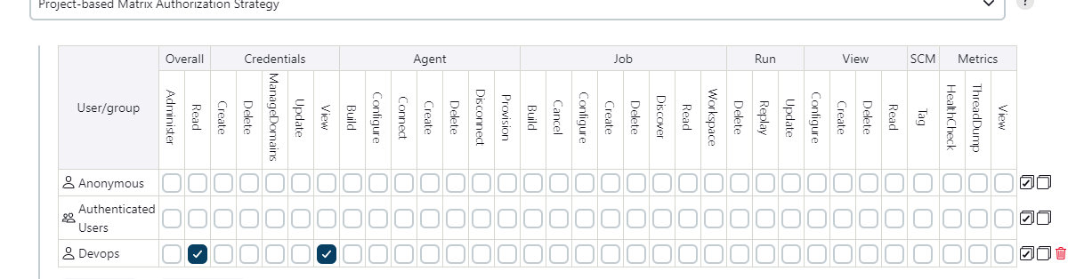

1. Configure labels and restrict the jobs to execute based on label only.

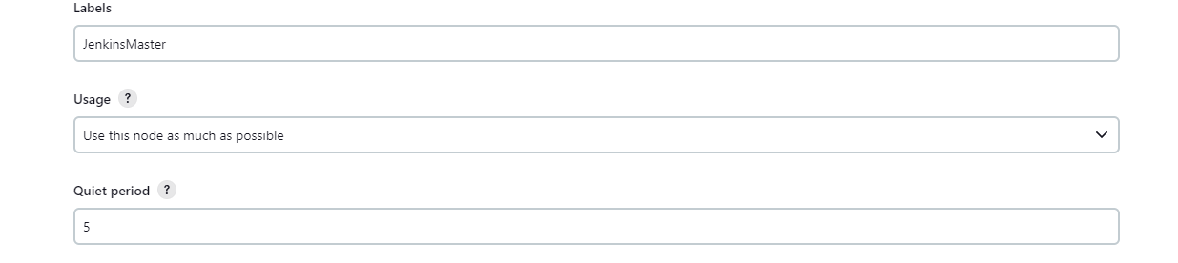

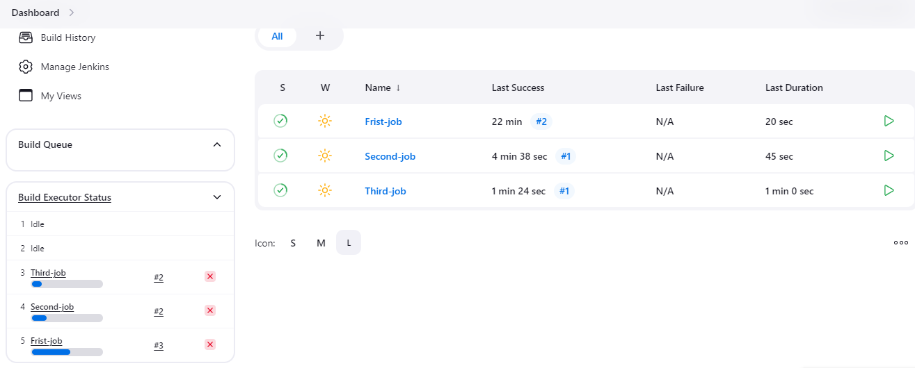

1. Create Three sample jobs using the below URL. <https://github.com/betawins/Techie_horizon_Login_app.git>

Creating a sample jobs using the above link step-1 go to first job then click on “Configure”

Step-2 Go to “source code management” and select GIT

Step-3 Build Now and will get the output. Same as well more 2.

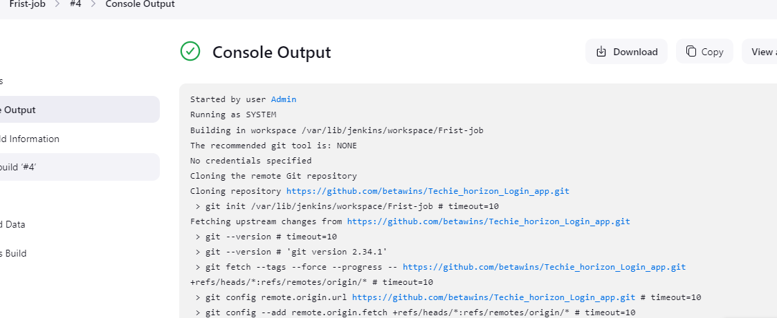

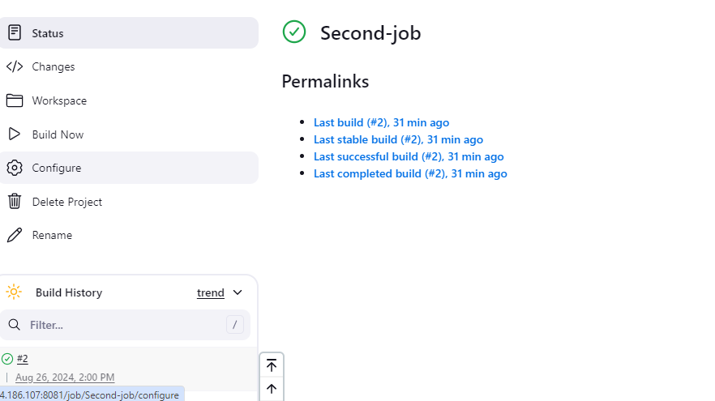

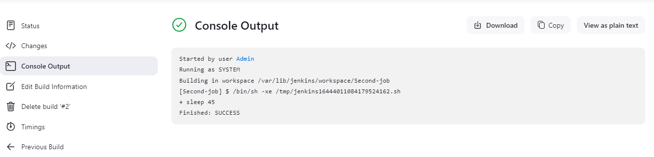

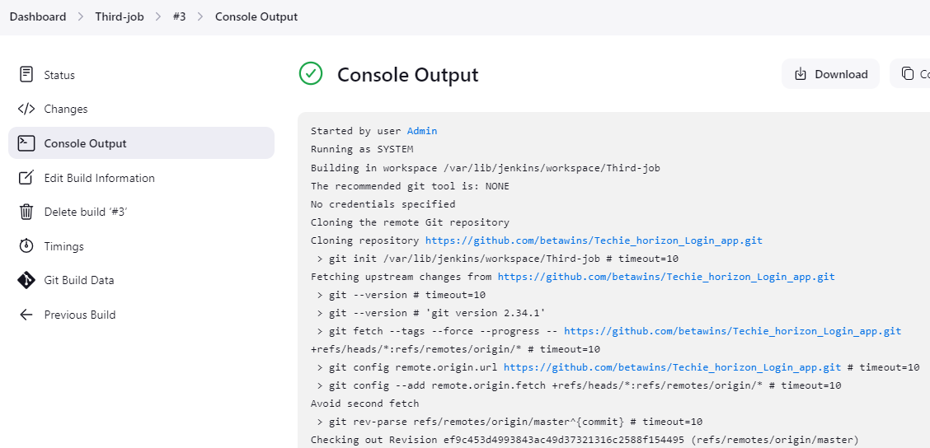

1. Create one Jenkins job using git hub Private repository.

